UNIVERSITY ROLLNO. 20139940



ARYABHATTA COLLEGE

COMPUTER SCIENCE DEPARTMENT

# COURSE : B. Sc. (h) Computer Science NAME : MUSKAN SAINI

COURSE : B.SC. (HONS.) COMPUTER SCIENCE NAME : ANIKA

YEAR : III SEMESTER : V

UNIVERSITY ROLL NO. : 21059570062 SESSION : 2023-2024

PROFESSOR : DR. SONAL LINDA

YEAR: III SEMESTER: V

# COLLEGE ROLLNO. : CSC/20/69 SESSION: 2022-2023

PROFESSOR: DR. SONAL LINDA

Micro Processor Practical FILE

1

UNIVERSITY ROLLNO. 20139940

INDEX

|  |  |  |  |
| --- | --- | --- | --- |
| SNO | PRACTICALS | FILE NAME | P.NO |
| 1 | Write a program for 32-bit binary  (i) Addition (ii) Subtraction (iii) division and (iv) Multiplication |  | 3-15 |
| 2 | Write a program for 32-bit BCD (i)Addition and (ii) Subtraction |  | 16-22 |
| 3 | Write a program for Sorting |  | 23-27 |
| 4 | Write a program for  (i) linear search and (ii) Binary search |  | 28-36 |
| 5 | Write a program to  (i)Add two arrays (ii) Subtract two array |  | 37-39 |
| 6 | Write a program for binary to ascii conversion |  | 40-42 |
| 7 | Write a program for ascii to binary conversion |  | 43-47 |

UNIVERSITY ROLLNO. 20139940

# Q1.Write a program for 32-bit binary

(i)Addition (ii) Subtraction (iii) division and (iv) Multiplication

CODE

;32 bit binary addition

.model small

.386

.data

num1 DD 00000000H num2 DD 00000000H num3 DD 00000000H

msg db 10,13,"Enter the first no.:: $" msg1 db 10,13,"Enter the second no.:: $" msg2 db 10,13,"The Resultant sum is :: $"

.code

.startup MOV AH,09

MOV DX,OFFSET msg INT 21H

MOV EBX,0 MOV CX,8

AGAIN: MOV AH,01 ;1ST NO. ENTERED INT 21H

UNIVERSITY ROLLNO. 20139940

CMP AL,'A' JGE L2 SUB AL,30H SHL EBX,4 ADD BL,AL LOOP AGAIN

MOV num1,EBX MOV AH,09

MOV DX,OFFSET msg1 INT 21H

MOV EBX,0 MOV CX,8

AGAIN1:MOV AH,01 ;2nd NO. ENTERED INT 21H

CMP AL,'A' JGE L2 SUB AL,30H SHL EBX,4 ADD BL,AL

LOOP AGAIN1 MOV num2, EBX

UNIVERSITY ROLLNO. 20139940

mov ax, word ptr num1 mov dx, word ptr num2 add al,dl

daa

mov bl,al mov al,ah adc al,dh daa

mov bh,al

mov word ptr num3, bx mov ax, word ptr num1+2 mov dx, word ptr num2+2 adc al,dl

daa

mov bl,al mov al,ah adc al,dh daa

mov bh,al

mov word ptr num3+2,bx mov ebx,num3

mov ah, 09h

UNIVERSITY ROLLNO. 20139940

mov dx, offset msg2 int 21h

jnc l6

mov ah, 02h mov dl, "1" int 21h

l6: MOV CX,8 AGAIN2: ROL EBX,4 MOV DL,BL

AND DL,0FH ADD DL,30H MOV AH,02 INT 21H LOOP AGAIN2 L2: .EXIT END

UNIVERSITY ROLLNO. 20139940

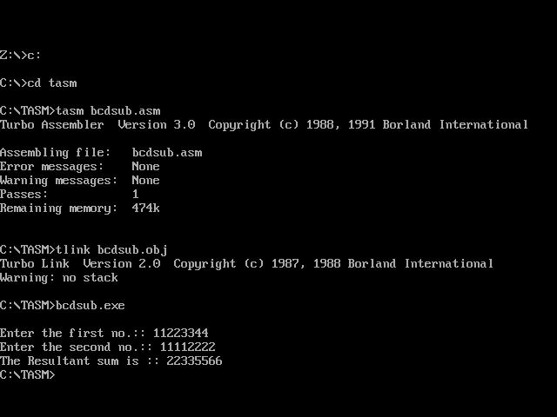

UNIVERSITY ROLLNO. 20139940

Code:

;32 bit binary subtraction

.model small

.386

.stack 100h

.data

num1 DD 00000000H num2 DD 00000000H num3 DD 00000000H

msg db 10,13,"Enter the first no.:: $" msg1 db 10,13,"Enter the second no.:: $"

msg2 db 10,13,"The Resultant Difference is :: $"

.code

.startup

MOV AH,09

MOV DX,OFFSET msg INT 21H

MOV EBX,0 MOV CX,8

AGAIN: MOV AH,01 ;1ST NO. ENTERED INT 21H

CMP AL,'A' JGE L2 SUB AL,30H SHL EBX,4 ADD BL,AL LOOP AGAIN

MOV num1,EBX MOV AH,09

UNIVERSITY ROLLNO. 20139940

MOV DX,OFFSET msg1 INT 21H

MOV EBX,0 MOV CX,8

AGAIN1:MOV AH,01 ;2nd NO. ENTERED INT 21H

CMP AL,'A' JGE L2 SUB AL,30H SHL EBX,4 ADD BL,AL

LOOP AGAIN1 MOV num2, EBX

mov ah, 09h

mov dx, offset msg2 int 21h

mov ax, word ptr num1+2 mov dx, word ptr num2+2 sub al,dl

das

mov dl,al sbb ah,dh das

mov dh,al call disph

mov ax, word ptr num1 mov dx, word ptr num2 sub al,dl

das

mov dl,al sbb ah,dh das

mov dh,al

UNIVERSITY ROLLNO. 20139940

disph proc near mov cl,4

mov ch,4 disph1: rol ax,cl push ax and al,0fh add al,30h cmp al,'9' jbe disph2 add al,7 disph2: mov ah,2 mov dl,al int 21h pop ax dec ch jne disph1 ret

disph endp

.EXIT L2:

.EXIT END

UNIVERSITY ROLLNO. 20139940

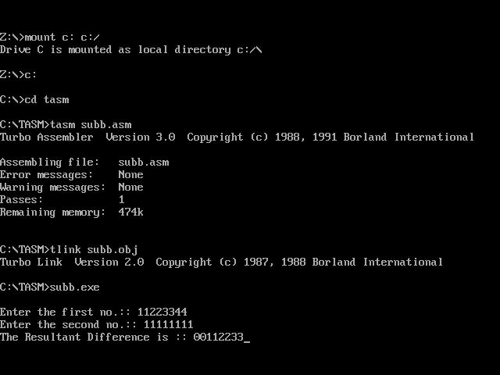

UNIVERSITY ROLLNO. 20139940

Code:

;32bit binary multiplication

.model tiny

.code

mov ax,04H mov bx,02H

mul bl DISP PROC

PUSH CX MOV CL, 4

MOv CH, 4

D1:

ROL AX, CL PUSH AX AND AL, 0FH

ADD AL , 30H CMP AL, '9'

JBE D2

ADD AL , 7H

D2:

MOV AH, 02H MOV DL, AL INT 21H POP AX

DEC CH JNZ D1 POP CX RET

DISP ENDP

.exit End

UNIVERSITY ROLLNO. 20139940



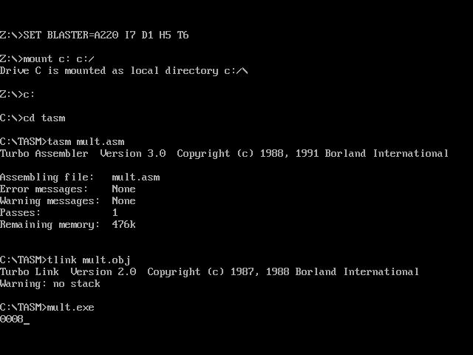

UNIVERSITY ROLLNO. 20139940

CODE:

;32bit binary division

.model tiny

.code

mov ax,02H mov bx,04H

div bl DISP PROC

PUSH CX MOV CL, 4

MOv CH, 4

D1:

ROL AX, CL PUSH AX AND AL, 0FH

ADD AL , 30H CMP AL, '9'

JBE D2

ADD AL , 7H

D2:

MOV AH, 02H MOV DL, AL INT 21H POP AX

DEC CH JNZ D1 POP CX RET

DISP ENDP

UNIVERSITY ROLLNO. 20139940

.exit End



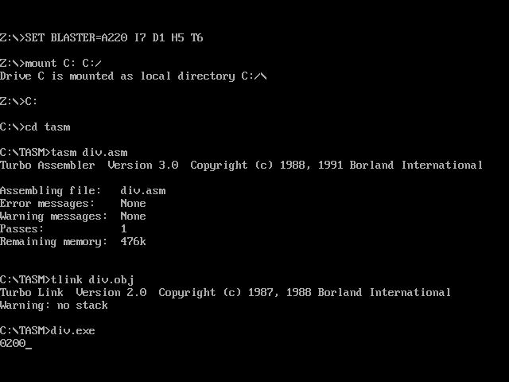

UNIVERSITY ROLLNO. 20139940

# Q2.Write a program for 32-bit BCD (i)Addition and (ii) Subtraction

Code:

;32bit bcd subtraction

.model small

.data

num1 db 10,"number1 : $" num2 db 10,"number2 : $" diff db 10,"Difference : $"

.code

.startup

mov dx , offset num1 mov ah, 9h

int 21h

mov ax,3333h call disph mov ax,3333h call disph

mov dx,offset num2 mov ah,9h

int 21h

mov ax,1111h

UNIVERSITY ROLLNO. 20139940

call disph mov ax,1111h call disph call sub_num

.exit

sub_num proc near mov dx,1111h

mov bx,3333h mov cx,1111h mov ax,3333h sub al,cl das

mov cl,al sbb ah,ch mov al,ah das

mov ch,al mov si,cx mov al,bl sbb al,dl

UNIVERSITY ROLLNO. 20139940

das

mov bl,al mov al,bh sbb al,dh das

mov bh,al

mov dx,offset diff mov ah,9h

int 21h mov ax,si call disph mov ax,bx call disph

ret

sub_num endp

disph proc near mov cl,4

mov ch,4 disph1:

UNIVERSITY ROLLNO. 20139940

rol ax,cl push ax and al,0fh add al,30h cmp al,'9' jbe disph2 add al,7 disph2: mov ah,2 mov dl,al int 21h pop ax dec ch jne disph1 ret

disph endp End

UNIVERSITY ROLLNO. 20139940

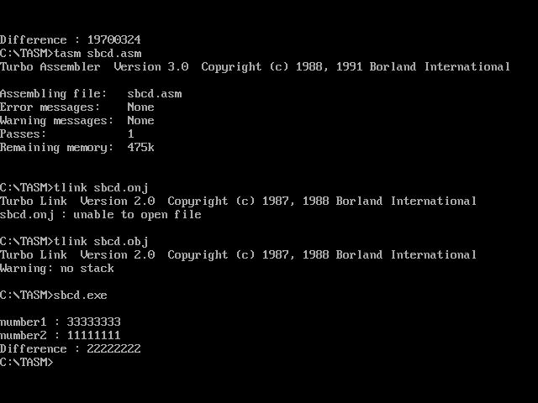

UNIVERSITY ROLLNO. 20139940

Code:

;32bit bcd additon

.MODEL SMALL ;assembler memory model

.STACK 100H

.DATA

MSG1 DB "4 DIGIT BCD SUM IS = $" BCDSUML DB ?

BCDSUMH DB ?

.CODE

MOV AX,@DATA MOV DS,AX

XOR AX, AX ; clear register AX MOV AL,34H

MOV BL, 98H ADD AL,BL

DAA; DECIMAL ADJUST AFTER ADDITION MOV BCDSUML, AL

MOV AL,12H MOV BL, 23H ADC AL,BL

DAA; OPERATES ONLY ON AL MOV BCDSUMH,AL

MOV AH,BCDSUMH MOV AL,BCDSUML PUSH AX

Page 19 of 43MOV DX, OFFSET MSG1 MOV AH, 09H

INT 21H ; INT STANDS FOR INTERRUPT INSTRUCTION 21H IS INTERRUPT NO FOR DOS SERVICES

POP AX

CALL DISPLAY MOV AH, 4CH INT 21H

DISPLAY PROC NEAR ; PROC IS KEYWORD FOR PROCEDURE MOV CH, 04H

MOV CL, 04H DISP1:

ROL AX, CL ; ROTATE LEFT 4 TIMES

UNIVERSITY ROLLNO. 20139940

PUSH AX ; SAVING ON STACK AND AL, 0FH

ADD AL, 30H ; 48 IN DECIMAL

CMP AL, '9' ; COMPARE WITH ASCII VALUE OF 9 JBE DISP2

ADD AL, 7

DISP2: MOV DL, AL MOV AH, 02H

INT 21H POP AX DEC CH JNZ DISP1 RET

DISPLAY ENDP END

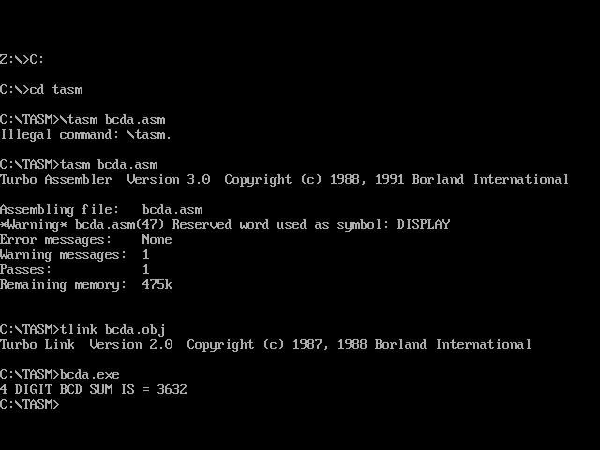

UNIVERSITY ROLLNO. 20139940

Q.3Write a program for Sorting?

Code:

;sorting

.model small

.386

.data

ARRAY DW 20 DUP (?) DATA1 dw 0000H NUMB DW 0000H

msg db 10,13,"Enter the size of the array :: $" msg2 db 10,13,"Enter the array :: $"

msg3 db 10,13,"The sorted array is :: $"

UNIVERSITY ROLLNO. 20139940

.code

.startup MOV AH,09

MOV DX,OFFSET msg INT 21H

MOV AH,01 INT 21H SUB AL,30H MOV AH,0 MOV CX,AX

MOV DATA1,AX

MOV AH,09

MOV DX,OFFSET msg2 INT 21H

MOV AH,0 MOV SI, 0

MOV BX, OFFSET ARRAY

L1: MOV DL, 0AH ; jump onto next line MOV AH, 02H

INT 21H

MOV DX, SI ; input element of the array

UNIVERSITY ROLLNO. 20139940

MOV AH, 01H INT 21H SUB AL,30H MOV SI, DX

MOV [BX + SI], AX INC SI

LOOP L1

MOV CX, DATA1

MOV BX, OFFSET ARRAY MOV DI,CX

L2: MOV CX, DATA1

MOV NUMB, CX ; Change1

DEC NUMB ; Change2 MOV CX, NUMB ; change3 MOV SI, 0

L3: MOV AL, [BX + SI] CMP AL, [BX + SI + 1] JL L4

XCHG AL,[BX + SI + 1] MOV [BX + SI],AL

L4: INC SI

UNIVERSITY ROLLNO. 20139940

LOOP L3 DEC DI JNZ L2

MOV CX, DATA1 MOV SI, 0

MOV BX, OFFSET ARRAY MOV AH,09

MOV DX,OFFSET msg3 INT 21H

L5: MOV DL, 0AH ; jump onto next line MOV AH, 02H

INT 21H

MOV DX, [BX + SI] INC SI

ADD DL, 30H MOV AH, 02 INT 21H LOOP L5

.EXIT END

UNIVERSITY ROLLNO. 20139940



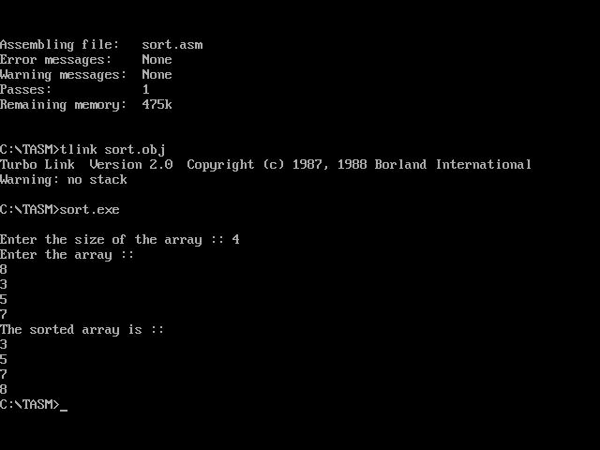

UNIVERSITY ROLLNO. 20139940

# Q4.Write a program for

(i) linear search and (ii) Binary search

;Linear Search

.model small

.386

.data

ARRAY DW 20 DUP (?)

DATA1 dw 0000H

success db 10,13,"Element is present in the array $" fail db 10,13,"Element is not present in the arary $" msg db 10,13,"Enter the size of the array :: $"

msg2 db 10,13,"Enter the array :: $"

msg3 db 10,13,"Enter the element to be searched :: $"

.code

.startup

UNIVERSITY ROLLNO. 20139940

MOV AH,09

MOV DX,OFFSET msg INT 21H

MOV AH,01 INT 21H SUB AL,30H MOV AH,0 MOV CX,AX

MOV DATA1,AX

MOV AH,09

MOV DX,OFFSET msg2 INT 21H

MOV AH,0 MOV SI, 0

MOV BX, OFFSET ARRAY

L1: MOV DL, 0AH ; jump onto next line MOV AH, 02H

INT 21H

MOV DX, SI ; input element of the array

UNIVERSITY ROLLNO. 20139940

MOV AH, 01H INT 21H

SUB AL,30H

;MOV SI, DX

MOV [BX + SI], AX INC SI

LOOP L1

MOV CX,DATA1

MOV AH,09

MOV DX,OFFSET msg3 INT 21H

MOV AH,01 ; Enter element to be searched INT 21H

SUB AL,30H MOV SI, 0

MOV BX, OFFSET ARRAY

L2: CMP [BX + SI], AL ; linear search loop JZ L3 ; jump if element is found

UNIVERSITY ROLLNO. 20139940

INC SI LOOP L2

MOV AH, 09H

MOV DX,OFFSET fail ; if the element is not found INT 21H

MOV AH, 4CH ; to forcefully terminate the program INT 21H

L3: MOV AH, 09H

MOV DX,OFFSET success ; if the element is found INT 21H

MOV AH, 4CH INT 21H

.EXIT END



UNIVERSITY ROLLNO. 20139940

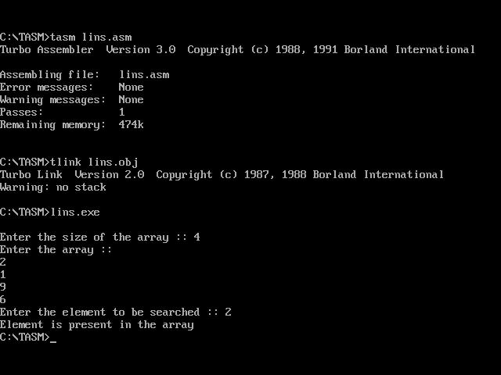

Code:

;Binary search

.model small

.386

.data

ARRAY DW 20 DUP (?) DATA1 dw 0000H DATA2 dw 0000H

success db 10,13,"Element is present in the array $" fail db 10,13,"Element is not present in the arary $" msg db 10,13,"Enter the size of the array :: $"

msg2 db 10,13,"Enter the array :: $"

msg3 db 10,13,"Enter the element to be searched :: $"

UNIVERSITY ROLLNO. 20139940

.code

.startup MOV AH,09

MOV DX,OFFSET msg INT 21H

MOV AH,01 INT 21H SUB AL,30H MOV AH,0 MOV CX,AX

MOV DATA1,AX

MOV AH,09

MOV DX,OFFSET msg2 INT 21H

MOV AH,0 MOV SI, 0

MOV BX, OFFSET ARRAY

L1: MOV DL, 0AH ; jump onto next line MOV AH, 02H

INT 21H

MOV DX, SI ; input element of the array

UNIVERSITY ROLLNO. 20139940

MOV AH, 01H INT 21H SUB AL,30H MOV SI, DX

MOV [BX + SI], AX INC SI

LOOP L1

MOV AH,09

MOV DX,OFFSET msg3 INT 21H

MOV AH,01 ; Enter element to be searched INT 21H

SUB AL,30H

MOV DATA2,AX MOV CX,DATA1 MOV SI,0

MOV DI, DATA1 MOV BP, 0

MOV BX, OFFSET ARRAY

UNIVERSITY ROLLNO. 20139940

|  |  |  |
| --- | --- | --- |
| MOV | AX, | DATA1 |
| L2: | MOV | SI, DI |
| ADD | SI, | BP |
| MOV | AX, | SI |
| MOV | DL, | 2 |
| DIV | DL |  |

MOV AH,0 MOV DX,0 MOV SI,AX MOV DX,DATA2

CMP [BX + SI],DL JZ L3

CALL L4 LOOP L2 MOV AH, 09H

MOV DX,OFFSET fail ; if the element is not found INT 21H

MOV AH, 4CH ; to forcefully terminate the program INT 21H

L3: MOV AH, 09H

UNIVERSITY ROLLNO. 20139940

MOV DX,OFFSET success ; if the element is found INT 21H

MOV AH, 4CH INT 21H

L4 PROC NEAR CMP [BX+SI], DL JL L6

MOV DI, SI RET

L6: MOV BP,SI RET

L4 ENDP

.EXIT END



UNIVERSITY ROLLNO. 20139940

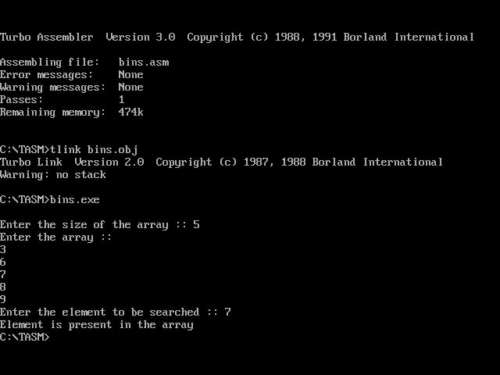

# Q5Write a program for binary to ascii conversion

Code:

;6. Write a program for binary to ascii conversion

.model small

.data

array db 8 dup(?)

msg db 0dh,0ah,'Program for conversion of binary to ascii:$'

msg1 db 0dh,0ah,'Enter the element to array:$'

.code

UNIVERSITY ROLLNO. 20139940

.startup

mov dx,offset msg mov ah,09h

int 21h

mov dx,offset msg1 mov si,0

mov cx,8 again:

mov ah,01h int 21h sub al,30h

mov array[si],al inc si

loop again

mov cx,8 mov al,01h mov sp,0h mov si,07h

UNIVERSITY ROLLNO. 20139940

mov bl,02h again1:

mov dl,array[si] cmp dl,01h

jz l2 here:

dec si mul bl

loop again1

jmp ext

l2:

add sp, ax jmp here

ext:

mov dx,sp mov ah,02h int 21h end

UNIVERSITY ROLLNO. 20139940

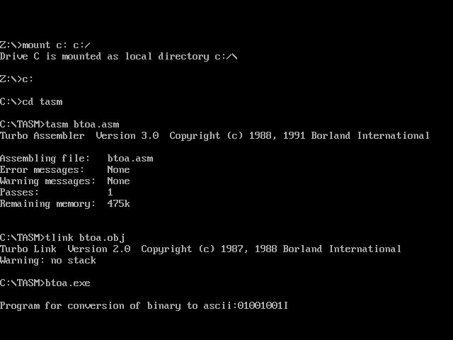

# Q6.Write a program for ascii to binary conversion

;Write a program for ascii to binary conversion.

.model small

.data

msg db 0dh,0ah,'Program for converting ASCII to Binary:$'

msg1 db 0dh,0ah,'Enter the element :$'

.code

UNIVERSITY ROLLNO. 20139940

.startup

mov dx,offset msg mov ah,09h

int 21h

mov dx,offset msg1 mov ah,09h

int 21h mov ah,01h int 21h mov bl,al mov dl,0Ah mov ah,02h int 21h mov cx,8 again:

shl bl,1 jc l2 jnc l3

loop again l2:

mov dl,31h mov ah,02h

UNIVERSITY ROLLNO. 20139940

int 21h jmp l4

l3:

mov dl,30h mov ah,02h int 21h jmp l4

l4:

loop again

End



UNIVERSITY ROLLNO. 20139940

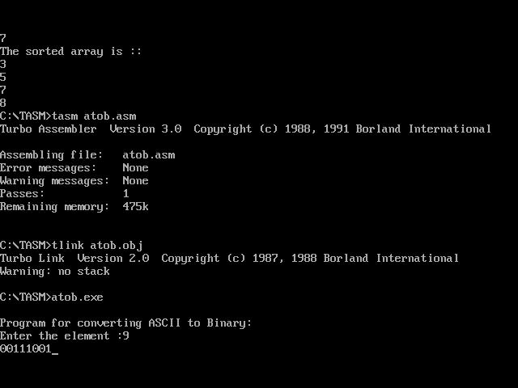

# Q7.Write a program two add and subtract two array Code:

;ARRRAY addition & subtraction

.model small

.stack 1000h

.data

UNIVERSITY ROLLNO. 20139940

arr1 db 05h, 06h, 07h, 09h, 09h arr2 db 01h, 01h, 01h, 01h, 01h diff db '$$'

sum db '$$$' space db ' $' endl db 0ah,'$'

.code

printSpace proc stdcall mov ah, 09h

mov dx, offset space int 21h

ret printSpace endp

printSum proc stdcall mov ah, 09h

mov dx, offset sum int 21h

call printSpace ret

printSum endp printSub proc stdcall

mov ah, 09h

UNIVERSITY ROLLNO. 20139940

mov dx, offset diff int 21h

call printSpace ret

printSub endp addition proc stdcall

mov cx, 5

mov si, 0 a:

xor bx, bx

mov bl, byte ptr[arr1+si] add bl, byte ptr[arr2+si]

cmp bl, 09h ja b

c:

or bx, 3030h

mov byte ptr[sum], bh mov byte ptr[sum+1], bl

call printSum inc si

UNIVERSITY ROLLNO. 20139940

loop a

ret

b:

xor ax, ax mov al, bl

sub al, 0ah ; sub bl, 09h dec bl inc ah

mov bx, ax jmp c

addition endp

subtraction proc stdcall mov cx, 5

mov si, 0 s:

xor ax, ax xor bx, bx

mov al, byte ptr[arr1+si] mov bl, byte ptr[arr2+si] sub al, bl

UNIVERSITY ROLLNO. 20139940

or al, 30h

mov byte ptr[diff], al

call printSub inc si

loop s ret

subtraction endp start:

mov ax, @data mov ds, ax mov es, ax call addition mov ah, 09h

mov dx, offset endl int 21h

call subtraction jmp last

last:

.exit 0 end start

UNIVERSITY ROLLNO. 20139940

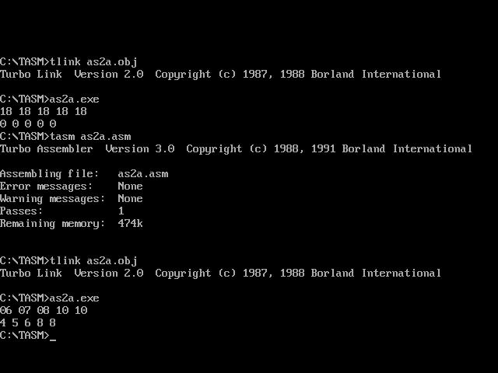

UNIVERSITY ROLLNO. 20139940